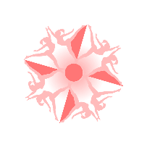
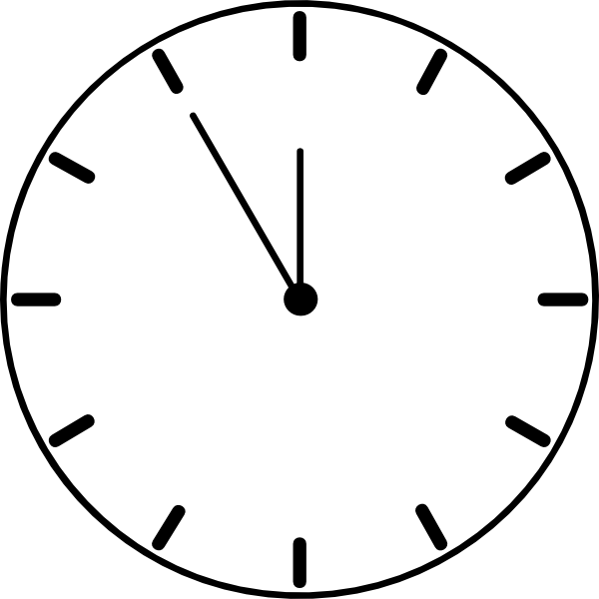
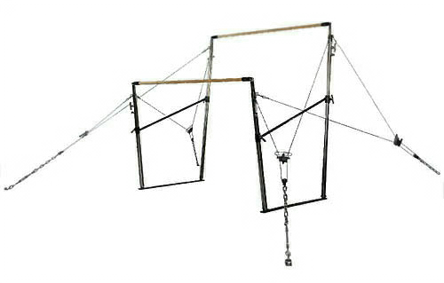
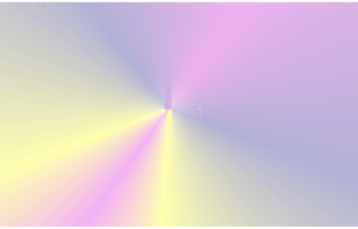

10°
10°

20° 20°
30° 30°

45°
45°
Vertical

90 Horizontal Horizontal 90°
15° Below Horizontal
30° Below Horizontal
30° Below Horizontal
15° Below Horizontal

Bar Angle Visualization Chart 2013 - 2017
Compiled by Brenda Eberhardt “Judging Things”for NAWGJ LIbrary August, 2013

Amp Turns AFTER HS
0° - 30° No Ded
Amp Casts Deductions
0 - 10° | “B “VP - No Ded
 |  |  | Amp Flight To HS on LB
11° - 20° | “B” VP & 0.05
 |  |  | 0° - 10° | No Ded
21° - 30° | No VP & 0.10
31° - 45° | No VP & 0.15 - 0.20 |  | 11° - 20° | 0.05
46° & Below | No VP & 0.25 - 0.30 |  | 21° & More | Lower VP
Clear Hip Circles ONLY Deductions
0° - 10° from Vert |  | No Ded & “C” VP
11° - 20° from Vert |  | 0.05 & “C” VP
21° - 45° from Vert |  | No Ded & “B” VP
46° - 89° from Vert |  | 0.05 - 0.25 & “B” VP
90° from Vert (Horiz) |  | 0.30 & “B” VP
More than 90° from Vert (Below Horiz) |  | 0.35 - 0.40 & “B” VP

31° - 45° 0.05 - 0.15
46° & Below 0.20 - 0.30
Amplitude Turns IN HS
^20° from Vert | No Ded
21° - 30° from Vert | 0.05 - 0.10
31° - 45° & Below | 0.15 - 0.20
46° from Vert | 0.25 - 0.30

Optional Angles are determined by their
execution from Vertical

Circling Elems but NOT CHC
0° - 10° No Ded & Higher VP 11° - 20° 0.05 & Higher VP 21° - 45° No Ded & Lower VP
46° from Vert ^0.20 & Lower VP

